**Title**

**Student name**

**Student Id: xxxxxxxxx**

**Student name**

**Student Id: xxxxxxxxx**

**Student name**

**Student Id: xxxxxxxxx**

**Student name**

**Student Id: xxxxxxxxx**



Department of Computer Science and Engineering

United International University

Dhaka, Bangladesh

December 2018

Abstract

<Delete all these content. Your abstract should go here.>All the pages have been formatted in the accepted font and margin alignment. This is a simple masters/undergraduateproject(to be completed in United International University) template that can be used for directly typing in your content.However, if you paste your text into the document, do so with caution as pasting could produce varying results. **When copy-pasting from another document, go to Paste -> Paste Special -> Unformatted Text**. This will not change the setting of this template. When directly typing into the title page and signature page, the appropriate information should be filled in the required fonts. Finally, this template has been prepared by Salekul Islam (CSE Department, UIU). Should you need further assistance, please contact Salekul at salekul@cse.uiu.ac.bd.

Table of Contents

<Delete this part>The table of contents is most easily created automatically (!!) with REFERENCE tools within WORD. Click on the following sequence: insert, reference, index and tables, table of contents, okay. The chapter titles and section headers should have been set to create a table of contents. It is important that the styles laid out in this template are used to maximize the benefits of the template and MS WORD options. The table of contents can be updated as you revise your by using right mouse button and clicking on “update field.” With this approach, there is no need to copy and paste or retype your chapter and section titles.

Abstract vii

1. Introduction 1
2. Cellular Technology 2

2.1 Sub header (Heading 2) 2

2.1.1 Sub-sub heading (Heading 3) 2

2.2 Equations 3

2.3 Tables 3

2.4 Figures 3

1. Conclusion 8

References 9

Chapter 1

# Introduction

The main goal of your introduction is to identify a problem that is worthy of investigation. It must also provide some idea of your research goals and approach to research. Specific objectives can be introduced in the introduction chapter or they can be saved for later after you’ve provided additional background on the topic and state of the current research and its gaps. The Introductory chapter often concludes with a summary of the organization of the , including identification of the general content of specific chapters and appendices.

Ideally, chapter one defines the overall importance of the problem areas and provides an introduction into what you did, chapter two is why you did it in the context of what was previously known, three is how you did it, four is what you found and five is what it all means – putting the pieces together, (what’s your contribution to the research field).

It should be noted that the objectives of your research define the OUTCOME, i.e. what will be learned. They are not a statement of the approach or tasks that are required to meet these objectives.

This template uses the MS WORD STYLES extensively to help keep your work in the proper format. **These paragraphs use the “-body text” style that is set for Times New Roman, 12 point font with 1.5 spaced lines and extra spacing between paragraphs (no need for hard carriage returns). There are also styles for headers, equations, captions and bulleted lists that you can choose to use. See examples throughout this template.**

Begin typing or pasting the rest of your chapter 1 text here. (and then deleting above text)

Chapter 2

# Cellular Technology

The background and literature review section needs to provide sufficient fundamental background information about the subject to support your objectives, hypo (or research questions) and methods, and review the pertinent literature related to the specific problem/hypo you are addressing.Some of the questions that he listed that the literature review should be to answer include:

* what are the fundamental science, math, engineering concepts related to your research (scope),
* what part of your research work has ever been investigated before and what has not, (some of this may have been included in the introduction)
* how does your research work relate to that done by others,
* how have others defined/measured/identified the key concepts of your research,
* what data sources have you used or have other researchers used in developing general explanations for observed variations in a behavior or phenomenon in a concept in your etc.

The lit review should not be limited to the above questions only. Ingeniousness and creativity is expected of a grad student.

Bullets can be single spaced. The above bullets are in the style “-bullets.” When you type bulleted text, highlight the bulleted text and then select “-bullets” from under the format, style menu to automatically change their formatting as above.

## 2.1 Sub header (Heading 2)

Given the length of each chapter, it is required to use headers and sub headers (possibly sub-sub headers).

### 2.1.1 Sub-sub heading (Heading 3)

The sub-sub headings here have a different format (“heading 3”) than the subheaders.

### 2.2 Equations

Equations can be created in MS WORD equation editor or they can be created with other software. Equations should be numbered. They can be numbered within each chapter (e.g., 2.1, 2.2) or they can be numbered sequentially throughout the entire . Equations should be indented or centered with the equation number to the right. The example below and associated “-eqn” style can be used for all your equations.

 [1]

This equation was written with the equation editor. Found through “insert, object, equation editor 3.0. The equation editor can also be found through “tools, customize, commands”, and in categories, look for insert and in the commands section, look for equation editor, drag and drop the icon onto the toolbar. This editor is fine for relatively simple equations, other options are available for more complex equations.

### 2.3 Tables

Tables should have meaningful information with descriptive headers. You can use the “Caption” style to define your captions and refer to the table in the text with a “cross reference” (Table 1). MS Word re-numbers table captions automatically when new tables inserted. But you need to right click on any cross references and “update field” if there are changes.

Table 1: Steps of creating a new table

|  |  |
| --- | --- |
| **Step #** | **Instruction** |
| Create table caption | Insert, reference, caption, table |
| Format the caption | Format, style, “Caption” |
| Create table | Table, insert… |
| Format the table | The formatting of the table can vary, including use of single space as appropriate. Most journals require that tables are formatted using table style “Table Simple 1” format. |
| Reference the table from the text | With the cursor at the location you want to cite the table: insert, reference, cross reference, table, label and number only. |

### 2.4 Figures

Figures and illustrations are a necessary means of communicating technical information. Often times, figures included in the background/lit review section are copied from existing copyrighted information. In all cases, this is technically inappropriate without also receiving permission from the copyright owner. From experience, a good way is to copy your graphic (for example from PowerPoint or excel) and when pasting it into word, use the “paste special” “as an “enhanced metafile” (Figure 2). This also substantially reduces the resulting file size in comparison with pasting graphs in as excel graphics.

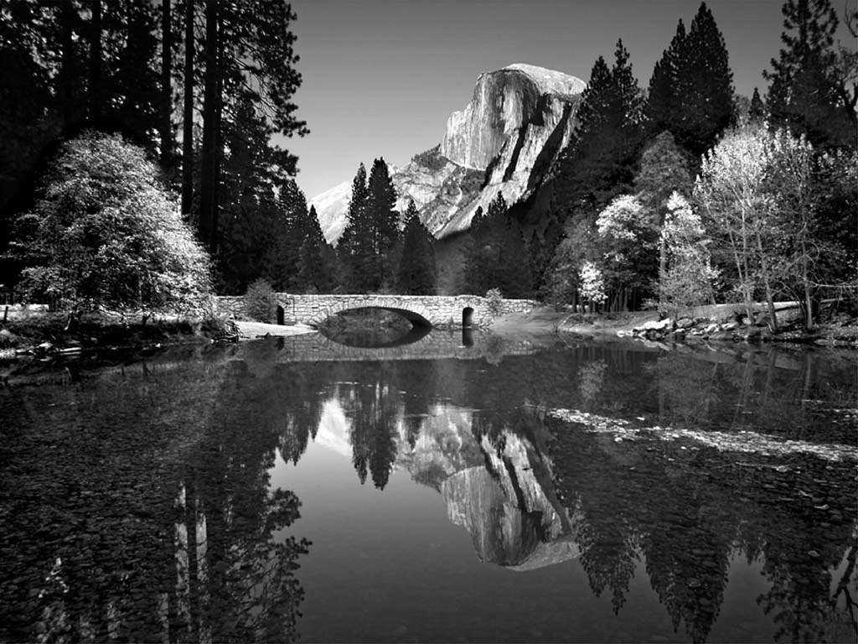

Figure 1: Example photo with high resolution. Caption created with “insert, reference, caption, figure” and the style changed to “Caption.”



Figure 2: Example of high resolution graphic inserted with “paste special, as enhanced metafile”

Chapter 3

# Conclusion

This chapter could also be called “Conclusions and Recommendations” or “Conclusions and Implications.” In general, there should be no new information presented here. It should be a syn of information that you’ve already discussed.

# References

<**Delete this part.>**Includes all references: articles, media facts, books, reports, regulations, internet articles, papers that you referenced from the text. In general, in Computer Science, we follow the IEEE style in writing the references and also in citing (in the body text, where you mention a reference). Hence, the citations should be numerical and sorted according to the appearance (i.e., the first citation should be [1], next one should be [2], etc.). Now, the hardest part in WORD is to maintain this numeric order, specially if your /report becomes a large file. For example, you want to cite a new reference in the middle of the . That means all subsequent citation should be increased to one!

Some examples are given below.

[1] P. Kessler, “Ericsson IMS client platform,” Ericsson Review, vol. 2, pp. 50–59, 2007.

[2] R. Levenshteyn, and I. Fikouras, “Mobile services interworking for IMS and XML Web Services,” IEEE Communications Magazine, pp. 80–87, Sep. 2006.

[3] D. Lozano, L.A. Galindo, and L. Garcia, “WIMS 2.0: Converging IMS and Web 2.0. Designing REST APIs for the exposure of session-based IMS capabilities,” in Proc. of The Second International Conference on Next Generation Mobile Applications, Services, and Technologies, 2008, pp. 18–24.

[4] G. Gehlen et al., “Mobile P2P Web Services using SIP,” Mobile Information Systems, vol. 3, pp. 165–185, 2007.

[5] “3rd Generation Partnership Project; Technical Specification Group Core Network and Terminals; Characteristics of the IP Multimedia Services Identity Module (ISIM) application”. 3GPP TS 31.103 V10.1.0, Apr. 2011.